THE UNIVERSITY OF AZAD JAMMU AND KASHMIR
Department of Software Engineering
Software Testing Lab (ST-3103)—
Node.js Installation and Playwright Setup
Lab Task #01
Student Name: Umair khan ikram
Roll Number: 2024_SET_27
Lab Instructor: Engr. Fahad Nisar
Semester: Fifth

Step 1: Install Node.js
Open https://nodejs.org/en/download and download the Windows Installer (.msi) for the LTS release. Run the installer, accept the license, keep the default options (including npm and Add to PATH), and finish installation.

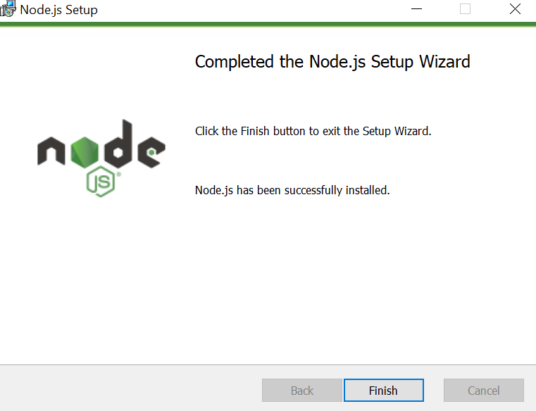

Step 2: Verify Node.js and npm
Open a NEW Command Prompt window and run each command.
node --version
npm --version

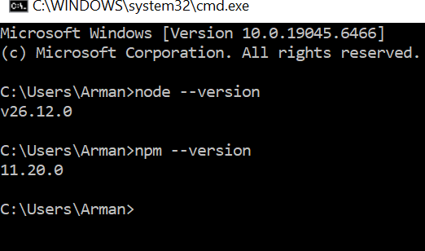

Step 3: Create the Project Folder
In Command Prompt, create and enter the project folder.
mkdir software-testing-lab
cd software-testing-lab
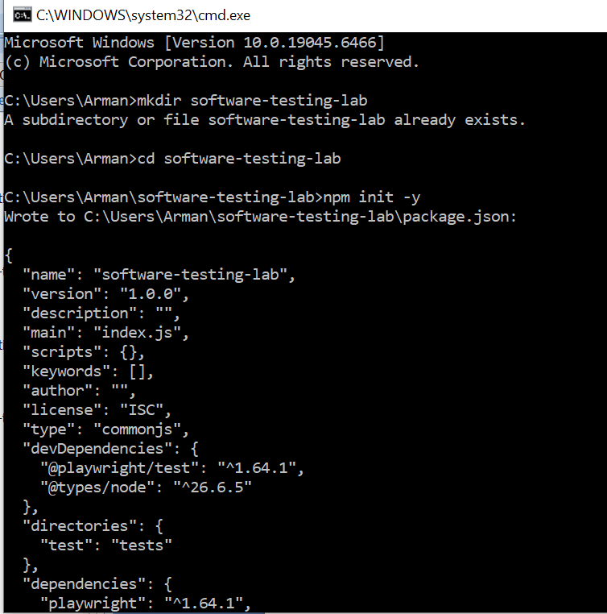

Step 4: Initialize the Node.js Project
Run the following command inside the project folder.
npm init -y

Step 5: Install and Initialize Playwright
Run the Playwright initializer. If prompted, choose JavaScript, use tests as the test folder, select No for GitHub Actions, and Yes to install Playwright browsers. Keep the internet connected.
npm init playwright@latest
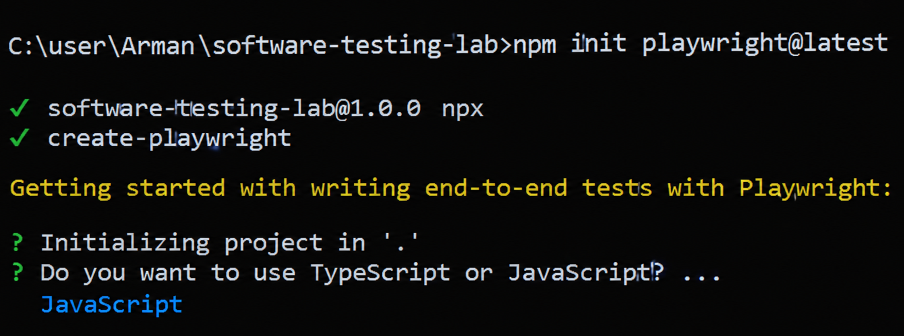

Step 6: Inspect the Project
Check the Playwright version, then open the software-testing-lab folder in File Explorer.
npx playwright --version
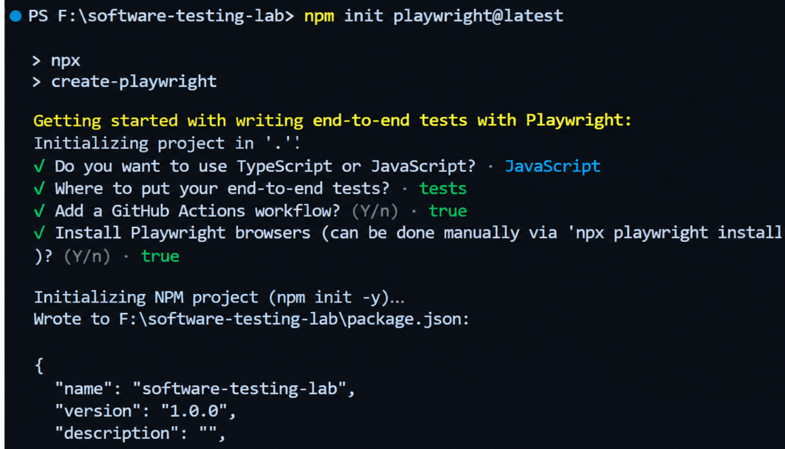

Step 7: Run the Sample Tests
Run the generated
sample tests from inside the project folder.
npx playwright test
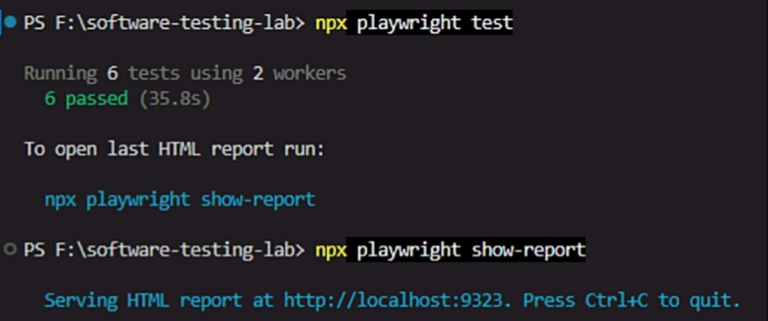

Step 8: View the HTML Report
After running the tests, open the report.
npx playwright show-report

